53. Create an alarm for a specific instance (e.g., monitoring a network load graph) and add it to an SNS topic to send email alerts.

54. Create an SNS topic and add an email address for notifications.

55. Create an SQS queue and subscribe it to the previously created SNS topic.

56. Verify if the messages are being sent correctly from SQS.

45. Create an alarm for a specific instance (e.g., monitoring a network load graph) and add it to an SNS topic to send email alerts.

1. created a alarm for a instance

* To create alarm, go to cloudwatch in dashboard
* In dashboard left side it has alarm
* Click create alarm
* Here , in arlarm we specificed EC2 instance

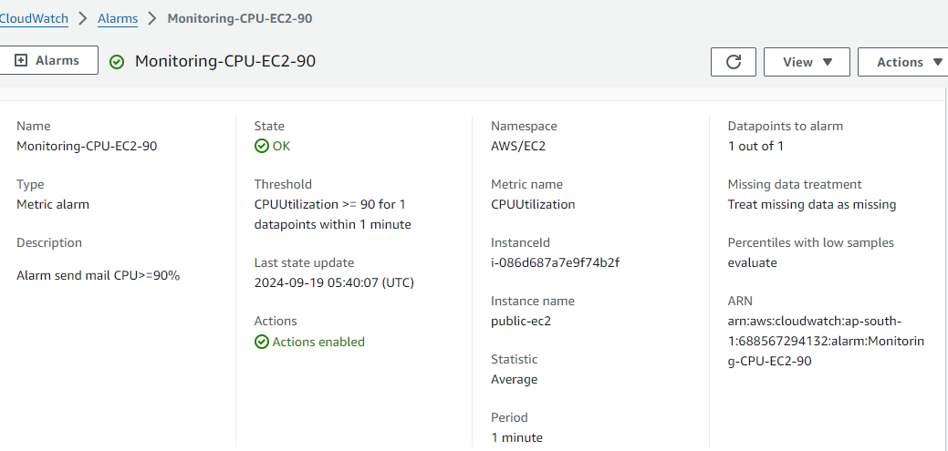

* After created alarm ,added to SNS topic to send email alerts

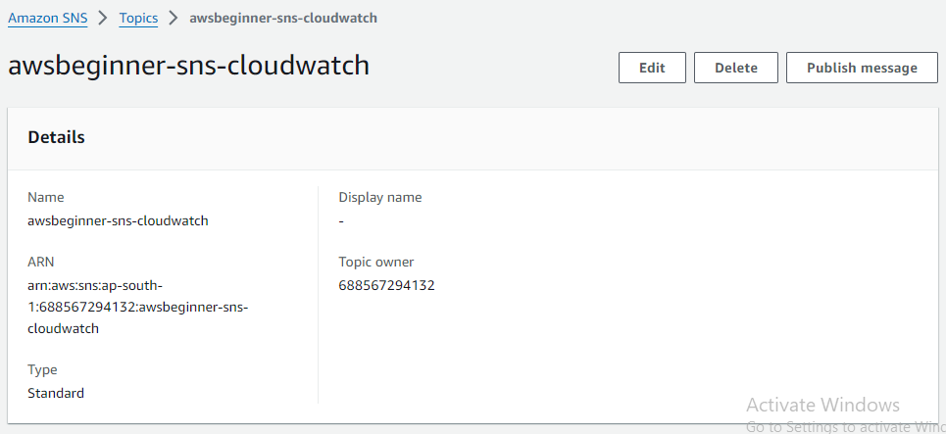

46. Create an SNS topic and add an email address for notifications.

Created SNS topic

* To create SNS topic ,go to SNS dashboard
* In dashboard left side ih has topic
* Go topic and click create topic

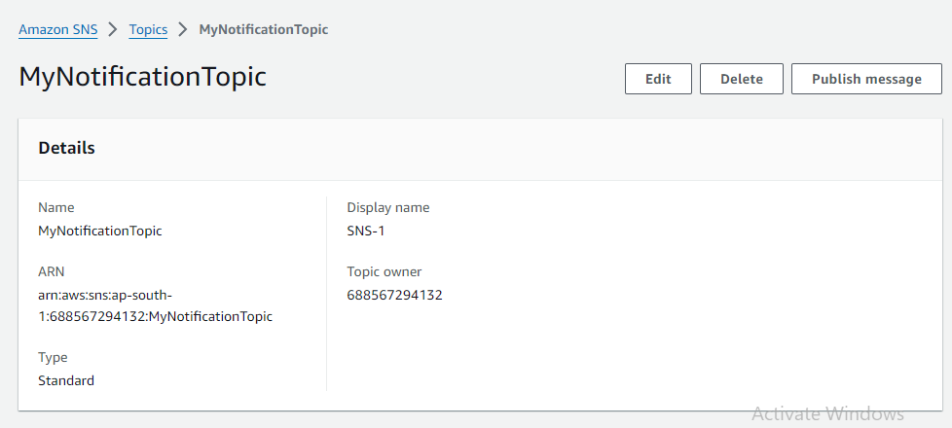

* In SNs topic added to email address to get notifications

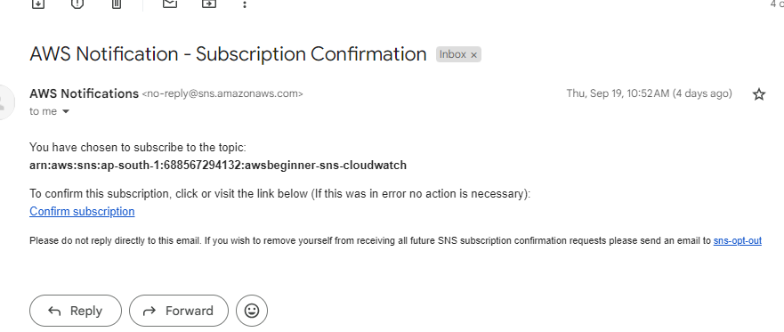

48. Verify if the messages are being sent correctly from SQS.

* Go to SQS dashboard and click queues
* Select the queue you want

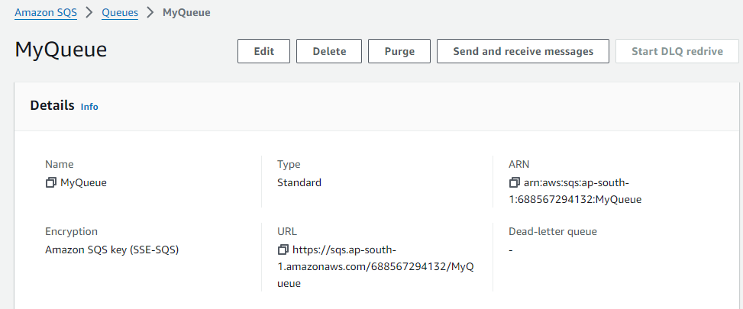

. **View and Receive Messages from the Queue**

• Click the **"Send and receive messages"** tab at the top of the queue’s detail page

* Send messages

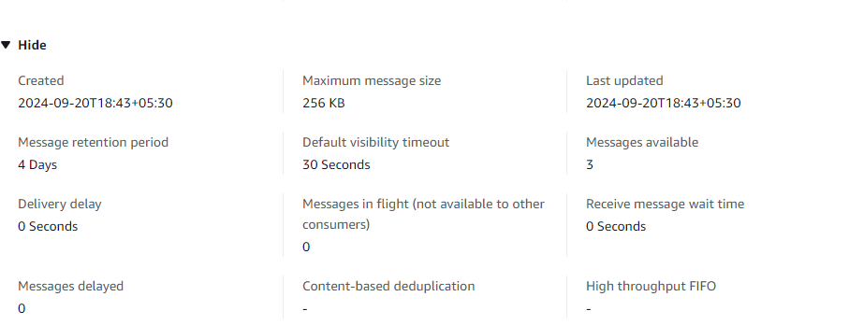

* Check the messages are receive or not





